Stuffed Animal Drive | December 2021 | Key Club  Stuffed animal drive where students and members of the Towson Community donated 181 used stuffed animals to the Maryland Emergency Pantry. | See below for pictures

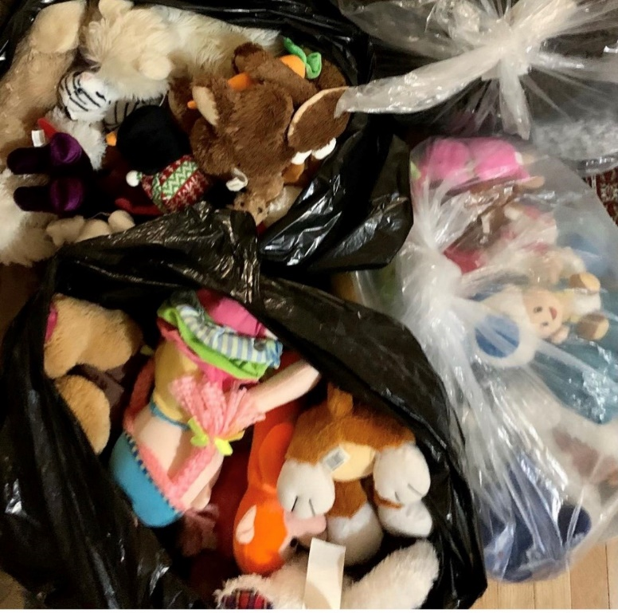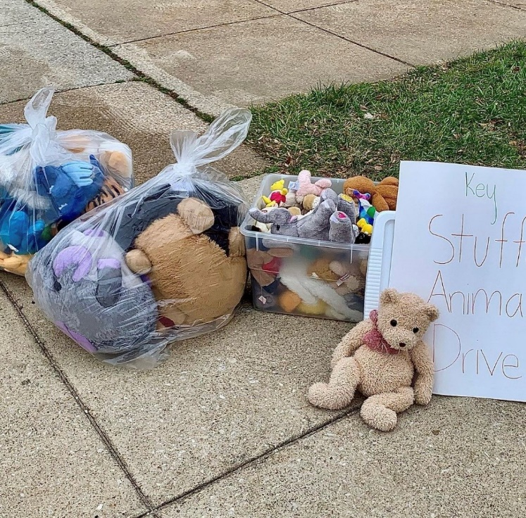
Stuffed Animal Drive

